M.S.SANJAY

15BCE0517

Q1.)

|  |  |  |  |  |
| --- | --- | --- | --- | --- |
| A | B | C | D | F |
| 0 | 0 | 0 | 0 | 0 |
| 0 | 0 | 0 | 1 | 0 |
| 0 | 0 | 1 | 0 | 0 |
| 0 | 0 | 1 | 1 | 0 |
| 0 | 1 | 0 | 0 | 0 |
| 0 | 1 | 0 | 1 | 0 |
| 0 | 1 | 1 | 0 | 0 |
| 0 | 1 | 1 | 1 | 0 |
| 1 | 0 | 0 | 0 | 0 |
| 1 | 0 | 0 | 1 | 0 |
| 1 | 0 | 1 | 0 | 0 |
| 1 | 0 | 1 | 1 | 1 |
| 1 | 1 | 0 | 0 | 0 |
| 1 | 1 | 0 | 1 | 1 |
| 1 | 1 | 1 | 0 | 1 |
| 1 | 1 | 1 | 1 | 0 |

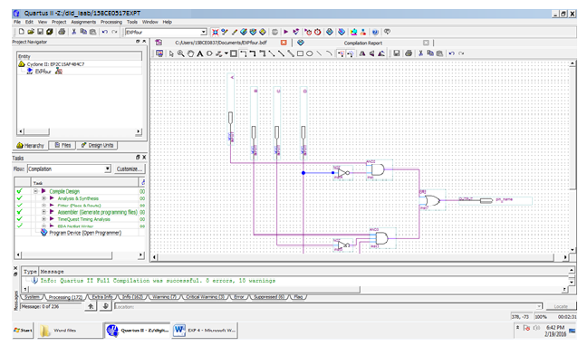

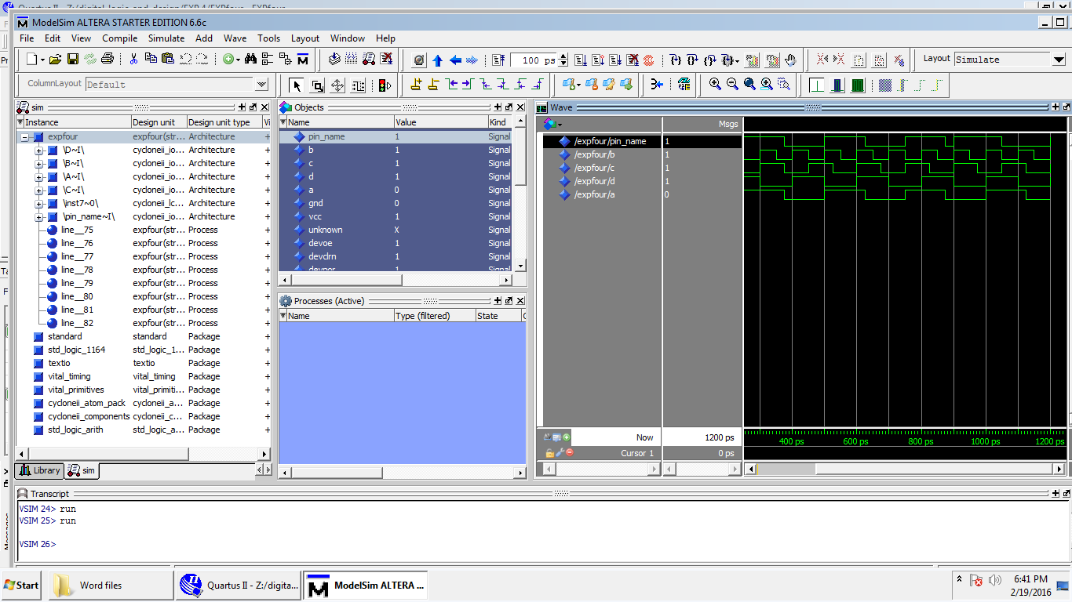

Q.2)

TRUTH TABLE:-

|  |  |  |  |  |  |
| --- | --- | --- | --- | --- | --- |
| A(SEC) | B(comp) | C | D | F | NO |
| 0 | 0 | 0 | 0 | 0 | 0 |
| 0 | 0 | 0 | 1 | 0 | 1 |
| 0 | 0 | 1 | 0 | 0 | 2 |
| 0 | 0 | 1 | 1 | 0 | 3 |
| 0 | 1 | 0 | 0 | 0 | 4 |
| 0 | 1 | 0 | 1 | 0 | 5 |
| 0 | 1 | 1 | 0 | 0 | 6 |
| 0 | 1 | 1 | 1 | 0 | 7 |
| 1 | 0 | 0 | 0 | 0 | 8 |
| 1 | 0 | 0 | 1 | 0 | 9 |
| 1 | 0 | 1 | 0 | 0 | 10 |
| 1 | 0 | 1 | 1 | 0 | 11 |
| 1 | 1 | 0 | 0 | 0 | 12 |
| 1 | 1 | 0 | 1 | 1 | 13 |
| 1 | 1 | 1 | 0 | 1 | 14 |
| 1 | 1 | 1 | 1 | 1 | 15 |

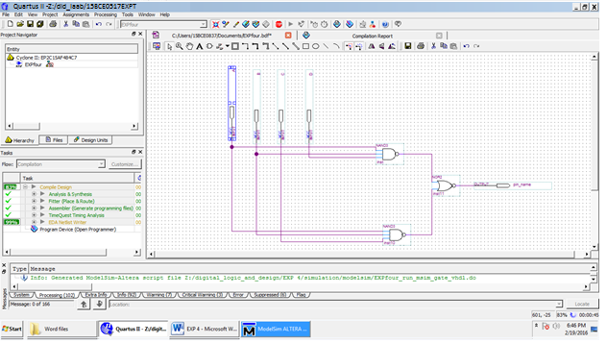

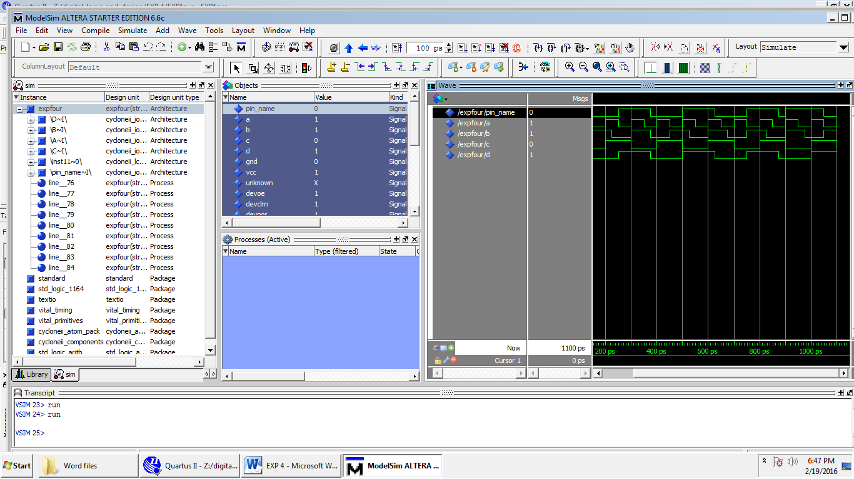

Q.3)

TRUTH TABLE

|  |  |  |  |  |
| --- | --- | --- | --- | --- |
| A(MOTHER) | B(SHOES) | C(RAINING) | F(OVER SHOES) | NO |
| 0 | 0 | 0 | 0 | 0 |
| 0 | 0 | 1 | 0 | 1 |
| 0 | 1 | 0 | 0 | 2 |
| 0 | 1 | 1 | 1 | 3 |
| 1 | 0 | 0 | 1 | 4 |
| 1 | 0 | 1 | 1 | 5 |
| 1 | 1 | 0 | 1 | 6 |
| 1 | 1 | 1 | 1 | 7 |

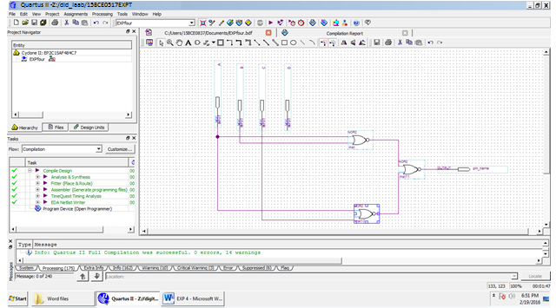

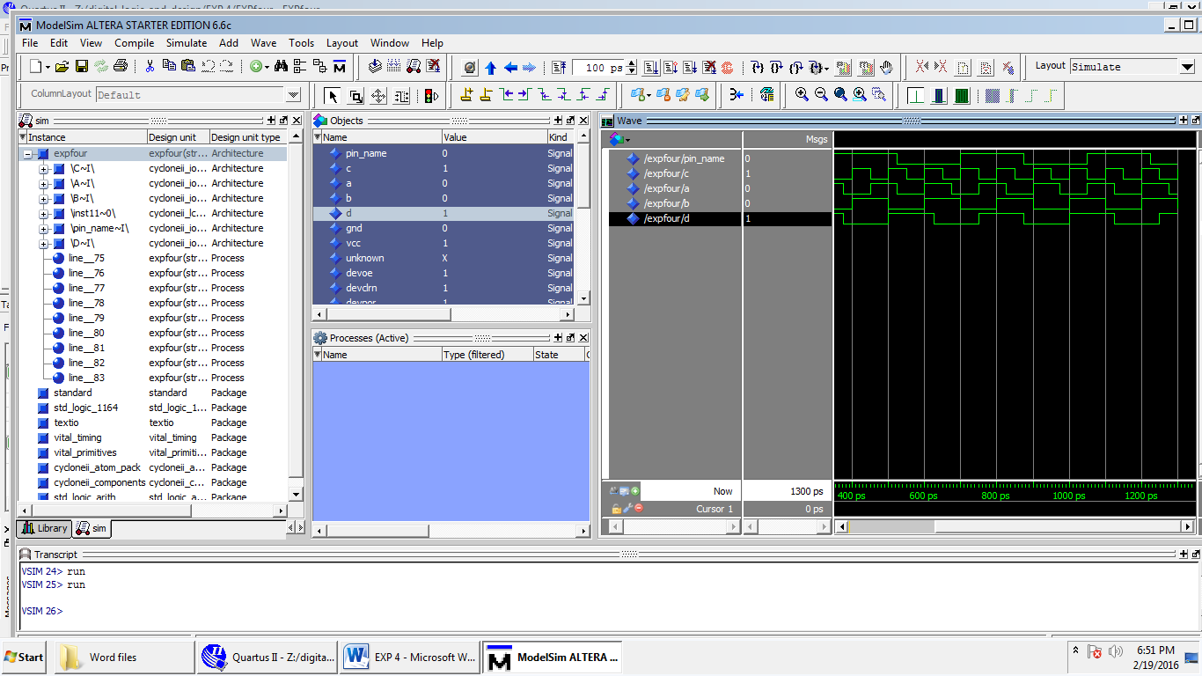

Q.4)

|  |  |  |  |  |  |  |
| --- | --- | --- | --- | --- | --- | --- |
| A | B | C | D | F | MIN | MAX |
| 0 | 0 | 0 | 0 | 0 | - | A+B+C+D |
| 0 | 0 | 0 | 1 | 0 | - | A+B+C+D’ |
| 0 | 0 | 1 | 0 | 0 | - | A+B+C’+D’ |
| 0 | 0 | 1 | 1 | 0 | - | A+B+C’+D’ |
| 0 | 1 | 0 | 0 | 1 | A’BC’D’ |  |
| 0 | 1 | 0 | 1 | 0 | - | A+B’+C+D’ |
| 0 | 1 | 1 | 0 | 0 | - | A+B’+C’+D |
| 0 | 1 | 1 | 1 | 0 | - | A+B’+C’+D’ |
| 1 | 0 | 0 | 0 | 1 | AB’C’D’ |  |
| 1 | 0 | 0 | 1 | 0 | - | A’+B+C+D’ |
| 1 | 0 | 1 | 0 | 0 | - | A’+B+C’+D |
| 1 | 0 | 1 | 1 | 0 | - | A’+B+C’+D’ |
| 1 | 1 | 0 | 0 | 1 | ABC’D’ |  |
| 1 | 1 | 0 | 1 | 1 | ABC’D |  |
| 1 | 1 | 1 | 0 | 1 | ABCD’ |  |
| 1 | 1 | 1 | 1 | 0 | - | A’+B’+C’+D’ |

